Estado del arte tecnologías de rastreo de contactos y distanciamiento social

# Tecnologías basadas en Wearables

|  |  |  |  |  |  |  |
| --- | --- | --- | --- | --- | --- | --- |
| **Product** | **Ranging technology** | **Contact Tracing** | **Indoor Localization** | **Complementary App/Software** | **API for third party Apps** | **Country** |
| [Estimote](https://estimote.com/wearable) | UWB | Yes | BLE beacons | Yes | No | USA |
| [TraceTogether](https://www.bbc.com/news/technology-53146360) | BLE | Yes | No | No, it is a smartphone replacement | No | Singapore |
| [Tsingoal](http://www.tsingoal.com/product_/show.php?lang=en&id=469&gclid=Cj0KCQjwpZT5BRCdARIsAGEX0zk-3J5ApGWjGZanHX61tzeJctT_PxzKFFoYpDsuIDVfQor97w9irbgaAkuXEALw_wcB) | UWB | Yes | No | Yes | No | China |
| [Safespacer](https://www.safespacer.net/) | UWB | Yes | No | Yes | No | Italy |
| [Rombit](https://rombit.be/covid-solutions/) | UWB | Yes | No | Yes | No | Belgium |
| [Proxxi Contact](https://www.proxxi.co/social-distancing-wristband) | UWB | Yes | No | Yes | No | Canada |
| [Blackline Tracing](https://www.blacklinesafety.com/contact-tracing) | ?? | Yes | BLE beacons | Yes | No | USA |
| [Samsung Smartwatch App](https://www.samsung.com/us/business/solutions/topics/wearables/social-distancing-management/) | RFID? | Yes | No | Yes | No | S. Korea |
| [Airista](https://www.airistaflow.com/hardware/) | BLE | Yes | No | Yes | No | USA |
| [Equivital](https://www.equivital.com/products/social-distancing-device) | UWB | Yes | No | Yes | Yes | USA |
| [Tended](https://www.tended.co.uk/social-distancing-solution) | UWB | Yes | No | Yes | No | UK |
| [Proximity Trace](https://www.triaxtec.com/resource/fact-sheet/proximity-trace/) | UWB? | Yes | No | Yes | No | USA |
| [Safespace](https://www.locilabs.co.uk/) | UWB | Yes | No | Yes | Yes | UK |
| [RightCrowd](https://www.rightcrowd.com/social-distancing-monitoring/?gclid=CjwKCAjwps75BRAcEiwAEiACMXpJ62ScmlGe7Z-weWNf_p2LweXs4TE8_CQpu6Z9xKqGTvoR2_jEGxoC3aIQAvD_BwE) | BLE | Yes | No | Yes | No | Australia |
| [AlertTrace](https://www.alerttrace.com/) | BLE | Yes | No | Yes | No | USA |
| [Losant](https://www.losant.com/contact-tracing-with-iot?utm_term=%2Bcontact%20%2Btracing&utm_campaign=hpn_search_ukeurope_contacttracing&utm_source=Google&utm_medium=cpc&hsa_acc=7426536783&hsa_cam=10390454612&hsa_grp=102856567909&hsa_ad=444648376530&hsa_src=g&hsa_tgt=kwd-310190982696&hsa_kw=%2Bcontact%20%2Btracing&hsa_mt=b&hsa_net=adwords&hsa_ver=3&gclid=CjwKCAjwps75BRAcEiwAEiACMR88GbBZ3tuZDclukiDHRvOXCw_7KtXBrSuvRCJ5uWQivS9plg1_VBoC7k4QAvD_BwE) | BLE | Yes | No | Yes | No | USA |

# Tecnologías basadas en Aplicaciones Móviles

* ASI Ecuador (Ecuador-Bluetooth Low Energy technology):

<https://www.eluniverso.com/noticias/2020/08/03/nota/7929402/asi-ecuador-app-monitoreo-coronavirus-bluetooth>

* Corona Warn (Alemania-Bluetooth Low Energy technology):

<https://www.coronawarn.app/en/>

* Aarogya Setu (India-Bluetooth):

<https://www.mygov.in/aarogya-setu-app/>

* StopCovid (Francia- Bluetooth Low Energy):

<https://www.france24.com/es/20200527-stopcovid-polemica-francia-app-rastreo-contagios>

* Artículo: A Survey of COVID-19 Contact Tracing Apps.

<https://arxiv.org/pdf/2006.10306.pdf>

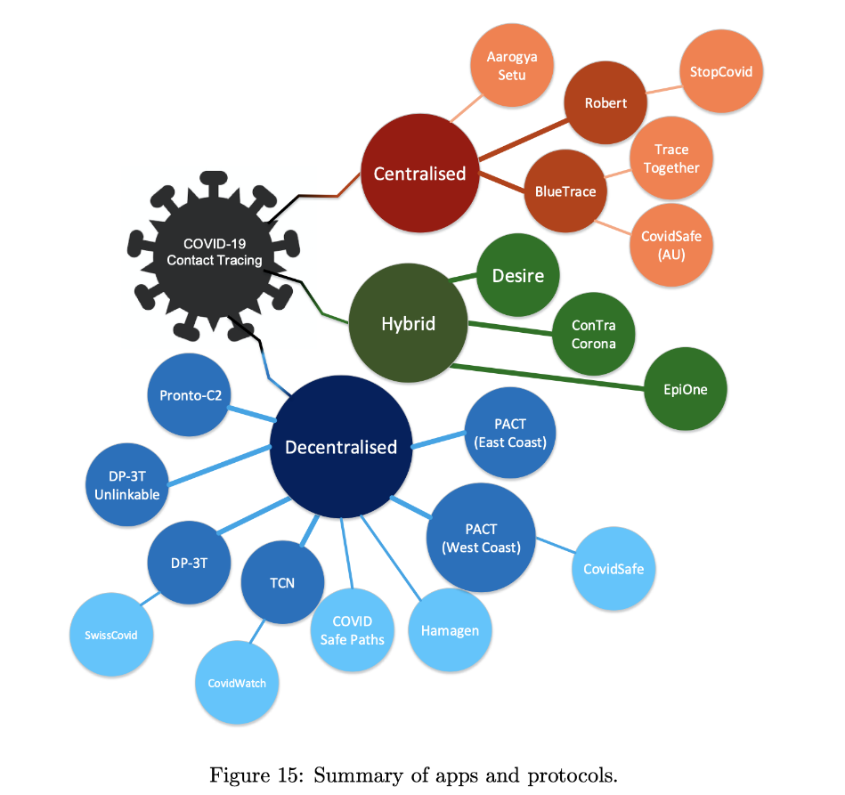

* Covid Tracing Tracker (Revista MIT-Apps):

<https://www.technologyreview.com/2020/05/07/1000961/launching-mittr-covid-tracing-tracker/>

En la Figura 1, se muestra un resumen de la base de datos de aplicaciones móviles creada por MIT:

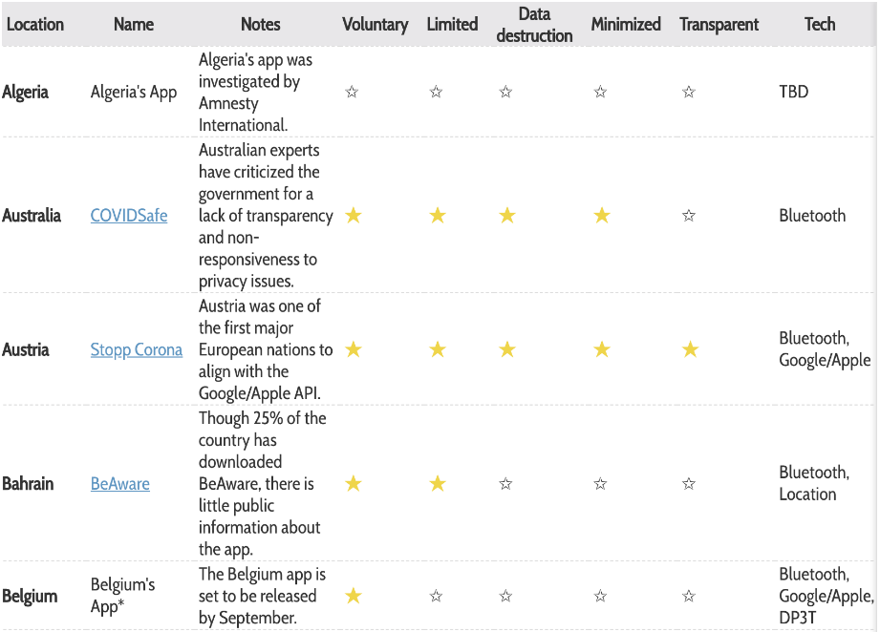

Fuente: <https://docs.google.com/spreadsheets/d/1ATalASO8KtZMx__zJREoOvFh0nmB-sAqJ1-CjVRSCOw/edit#gid=0>

* Artículo: COVID-19 Contact-tracing Apps: a Survey on the Global Deployment and Challenges.

# <https://arxiv.org/pdf/2005.03599.pdf>

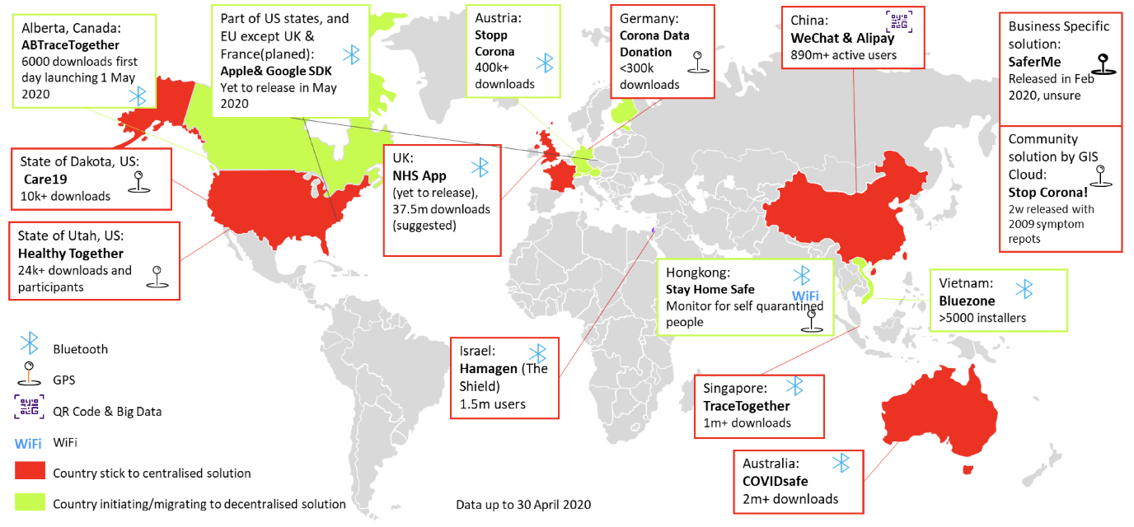

# Artículo: IoTrace: A Flexible, Efficient, and Privacy-Preserving IoT-enabled Architecture for Contact Tracing

# <https://arxiv.org/pdf/2007.11928.pdf>

* Articulo: Effective contact tracing for COVID-19 using mobile phones: An ethical analysis of the mandatory use of the Aarogya Setu application in India.

<https://www.cambridge.org/core/services/aop-cambridge-core/content/view/8A902BBEF6722241E28458BB70FC1195/S0963180120000821a.pdf/effective_contact_tracing_for_covid19_using_mobile_phones_an_ethical_analysis_of_the_mandatory_use_of_the_aarogya_setu_application_in_india.pdf>

* Artículo: A Privacy-preserving Mobile and Fog Computing Framework to Trace and Prevent COVID-19 Community Transmission

<https://ieeexplore.ieee.org/document/9204791>

* Artículo: COVID-19 Contact Trace App Deployments: Learnings From Australia and Singapore

<https://ieeexplore.ieee.org/document/9117157>

* Exploring Factors Influencing the Users’ Intention to Use *Aarogya Setu* Contact Tracing Mobile Health Application during COVID-19 Pandemic

[**https://horizon-jhssr.com/view-issue.php?id=60**](https://horizon-jhssr.com/view-issue.php?id=60)

* Artículo: A First Look at Privacy Analysis of COVID-19 Contact Tracing Mobile Applications

<https://ieeexplore.ieee.org/document/9199262>

* Articulo: Sentiment Analysis of User Feedback on the HSE Contact Tracing App

<https://assets.researchsquare.com/files/rs-96174/v1/fb542907-f4c4-45bc-abde-4cde26214d1c.pdf>

* Artículo: Behind COVID-19 Contact Trace Apps: The Google–Apple Partnership

<https://ieeexplore.ieee.org/document/9117186>

* Artículo: COVID-19 Mobile Contact Tracing Apps (MCTA): A Digital Vaccine or a Privacy Demolition?

<https://ieeexplore.ieee.org/document/9162209>

* Artículo: How Reliable is Smartphone-based Electronic Contact Tracing for COVID-19?

<https://arxiv.org/abs/2005.05625>

* Guía: Guidance on evaluating or developing a health app

<https://www.health.govt.nz/system/files/documents/pages/guidance-evaluating-developing-health-app-oct17-v2.pdf>

* Measuring the Quality of Mobile Apps for the Management of Pain: Systematic Search and Evaluation Using the Mobile App Rating Scale

<https://www.researchgate.net/publication/326551347_Measuring_the_Quality_of_Mobile_Apps_for_the_Management_of_Pain_Systematic_Search_and_Evaluation_Using_the_Mobile_App_Rating_Scale>

* Mobile App Rating Scale: A New Tool for Assessing the Quality of Health Mobile Apps

<https://www.researchgate.net/publication/273407216_Mobile_App_Rating_Scale_A_New_Tool_for_Assessing_the_Quality_of_Health_Mobile_Apps>

* BlueTrace: A privacy-preserving protocol for community-driven contact tracing across borders

<https://bluetrace.io/static/bluetrace_whitepaper-938063656596c104632def383eb33b3c.pdf>